**NETWORKING & SYSTEM ADMINISTRATION LAB**

**(20MCA136)**

# LAB RECORD

Submitted in partial fulfilment of the requirements for the award of the degree of Master of Computer Applications of A P J Abdul Kalam Technological University, Kerala.

**Submitted by:**

## JERRY JAMES (SJC23MCA-2036)



# MASTER OF COMPUTER APPLICATIONS

## ST.JOSEPH’S COLLEGE OF ENGINEERING AND TECHNOLOGY, PALAI

**CHOONDACHERRY P.O, KOTTAYAM**

**KERALA**

**May 2024**

# ST. JOSEPH’ S COLLEGE OF ENGINEERING AND TECHNOLOGY, PALAI

**(An ISO 9001: 2015 Certified College)**

**CHOONDACHERRY P.O, KOTTAYAM, KERALA**



## CERTIFICATE

This is to certify that the Networking & System Administration Lab Record (20MCA136) submitted by **Jerry** **James**, student of **Second** semester **MCA** at **ST. JOSEPH’S COLLEGE OF ENGINEERING AND TECHNOLOGY, PALAI** in partial fulfilment for the award of Master of Computer Applications is a bonafide record of the lab work carried out by him under our guidance and supervision. This record in any form has not been submitted to any other University or Institute for any purpose.

|  |  |
| --- | --- |
| **Dr. Rahul Shajan**  Associate Professor  **(**Head, Department of  Computer Application**)** | **Mr. Anish Augustine K**  Assistant Professor ,  Dept. of Computer Application  (Faculty In-Charge) |

Submitted for the End Semester Examination held on

**Examiner 1 Examiner 2**

## DECLARATION

I Jerry James, do hereby declare that the Networking & System Administration Lab Record (20MCA136) is a record of work carried out under the guidance of Mr. Anish Augustine K, Asst. Professor, Department of Computer Applications, SJCET, Palai as per the requirement of the curriculum of Master of Computer Applications Programme of A P J Abdul Kalam Technology University, Thiruvananthapuram. Further, I also declare that this record has not been submitted, full or part thereof, in any University / Institution for the award of any Degree / Diploma.

Place: Choondacherry JERRY JAMES

Date : (SJC23MCA-2036)

**DEPARTMENT OF COMPUTER APPLICATIONS**

**VISION**

To emerge as a center of excellence in the field of computer education with distinct identity and quality in all areas of its activities and develop a new generation of computer professionals with proper leadership, commitment and moral values.

**MISSION**

* Provide quality education in Computer Applications and bridge the gap between the academia and industry.
* Promoting innovation research and leadership in areas relevant to the socio economic progress of the country.
* Develop intellectual curiosity and a commitment to lifelong learning in students, with societal and environmental concerns.

**COURSE OUTCOMES**

After the completion of the course 20MCA136 Networking & System Administration Lab the student will be able to :

|  |  |  |
| --- | --- | --- |
| **CO 1** | Install and configure common operating systems. | K3  (Apply) |
| **CO 2** | Perform system administration tasks. | K3  (Apply) |
| **CO 3** | Install and manage servers for web applications. | K2  (Understand) |
| **CO 4** | Write shell scripts required for system administration. | K3  (Apply) |
| **CO 5** | Acquire skill sets required for a DevOps. | K3  (Apply) |

## CONTENT

|  |  |  |  |
| --- | --- | --- | --- |
| **Sl. No.** | **Program List** | **Page No.** | **Date** |
| **1** | Introduction to Computer hardware | 1 | 07-02-2024 |
| **2** | Install latest version of Ubuntu on a virtual box | 5 | 14-02-2024 |
| **3** | Study of a terminal based text editor such as Vim or Gedit, Basic Linux commands: - familiarity with following commands/operations expected | 20 | 21-02-2024 |
| **4** | Shell scripting | 29 | 28-02-2024 |
| **4.1** | Shell program to check the given number and its reverse are same. | 29 | 06-03-2024 |
| **4.2** | Shell program to find the sum of odd and even numbers from a set of numbers | 30 | 06-03-2024 |
| **4.3** | Shell program to find the roots of a quadratic equation | 31 | 07-03-2024 |
| **4.4** | Shell program to generate prime numbers between 1 and 50 | 32 | 07-03-2024 |
| **4.5** | Shell program to find the sum of digits of a number using function | 33 | 13-03-2024 |
| **4.6** | Shell program to print the reverse of a number using function | 34 | 13-03-2024 |
| **4.7** | Shell script, which receives two filenames as arguments. It checks whether the two files contents are same or not. If they are same then second file is deleted. | 35 | 14-03-2024 |
| **4.8** | Shell script to check executable rights for all files in the current directory, if a file does not have the execute permission then make it executable | 36 | 14-03-2024 |
| **4.9** | Shell program to create Pascal’s triangle | 37 | 20-03-2024 |
| **4.10** | Shell script to find out the unique words in a file and also count the occurrence of each of these words | 38 | 20-03-2024 |
| **5** | File system hierarchy in a common Linux distribution | 39 | 21-03-2024 |
| **6** | Installation and configuration of LAMP stack. Deploy in an open source application such as phpmyadmin and WordPress. | 42 | 27-03-2024 |
| **7** | Build and install software from source code, familiarity with make and cmake utilities expected | 49 | 03-04-2024 |
| **8** | Introduction to command line tools for networking IPv4 networking, network commands | 51 | 11-04-2024 |
| **9** | Analyzing network packet stream using tcpdump and Wireshark | 54 | 17-04-2024 |
| **10** | Introduction to Hypervisors and VMs, Xen or KVM  Introduction to Containers: Docker, installation and deployment | 56 | 24-04-2024 |
| **11** | Installing and configuring modern frameworks like Laravel | 59 | 02-05-2024 |
| **12** | Ansible play book deployment | 61 | 02-05-2024 |

1. **Introduction to Computer hardware: Physical identification of major components of a computer system such as mother board, RAM modules, daughter cards, bus slots, SMPS, internal storage devices, interfacing ports**.

**Procedure:**

**What is Computer Hardware?**

Computer hardware is a hardware part of a computer system. In simple words, only those parts of the computer system which we can see or touch are called computer hardware.

Hardware is an important part of our computer system without which the computer is incomplete. You cannot use a computer without hardware and without hardware, there cannot be a computer system or construction.

1. **Mouse**



A mouse is a hardware input device that is used to move the cursor or pointer on computer screens. It can also be used to run computer programs, select items in a graphical user interface, and manipulate objects in the computer world. Some common examples of how it can be used are clicking on buttons, scrolling up and down the screen, selecting files, opening folders, and so on.

1. **Keyboard**

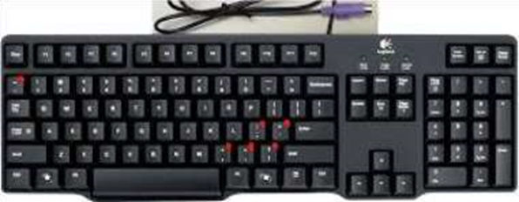 A keyboard is an input device that you use to enter data into a computer. It's also called the input device for your computer. Keyboards are used with PCs, laptops, tablets, and other devices. There are many different types of keyboards, but the most common one is the QWERTY keyboard. A QWERTY keyboard has all the letters in alphabetical order on it. This is different from some other types of keyboards, like Dvorak or Colemak keyboards. For example, these keyboards have keys arranged differently than what you’re used to seeing on a QWERTY keyboard. And that means that typing on these keyboards will feel like typing in another language at first! But don’t worry - once you get accustomed to it, it feels natural!

1. 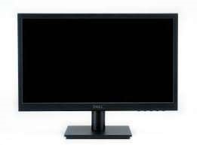**Monitor**

Personal computers use a monitor to display data, run the software, and interact with the user. A monitor is an electronic visual display that connects to your computer or laptop. It is used for displaying images, text, videos, games, web pages, and more. Monitors are available in different sizes depending on the needs of the person using them. The most common types of monitors are CRT (cathode ray tube), LCD (liquid crystal display), and LED (light-emitting diode).

1. 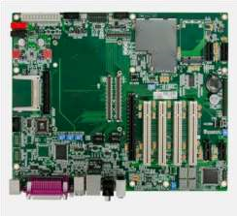**Motherboard**

The motherboard is the backbone of our computer system. It's the central processing unit or CPU. It connects all the other components, like memory and graphics card, to the power supply. The motherboard is where all the wires are plugged in and it's also where you place your RAM, which is your computer's working memory. The motherboard is what makes one machine different from another.

Motherboards are made up of tiny transistors that control the flow of electricity through copper tracks on their surface. These transistors are called Integrated Circuits or ICs for short.

1. **CPU (Central Processing Unit)**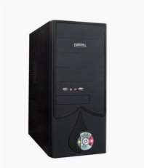

A CPU, or central processing unit, is the brain of a computer. The CPU processes information and runs programs. It functions as a control unit that executes programs according to instructions in its program memory. The CPU contains elements such as registers, an arithmetic logic unit (ALU), and control logic for sequencing instructions.

1. 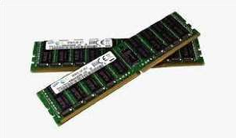**RAM Memory**

A computer's RAM is a type of computer memory that stores information so the CPU can access it directly. Computer systems use main memory to store both data and programs. The more RAM you have, the more data your system can process at one time. This will lead to more efficient operations on your computer, which translates into better performance for the user.

1. **ROM Memory**

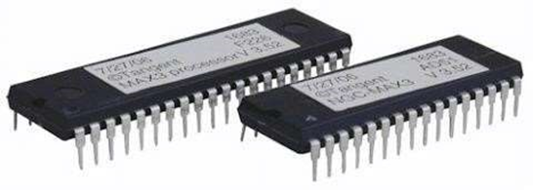

ROM stands for a type of memory chip that can be read from but not written to. In other words, it's a form of data storage that can't be changed after being programmed. It's sometimes called "non-volatile" memory because the stored information will remain even when not powered up or in use. ROM is often used to store a computer's basic start-up instructions and certain types of data, such as your car's on-board computer system and a calculator's data tables.

1. 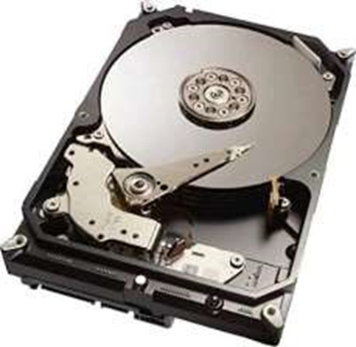**Hard Disk Drive**

A hard disk drive is a piece of hardware inside a computer that stores information. It’s used to store software and data in a safe place, which can be accessed when needed. With magnetic storage, there are no moving parts - unlike a CD or DVD player in which you need to move a disk in order to access data. You can think of it as "a closet" where all your stuff is stored safely. As long as you have power, you can get to your things when you need them.

1. 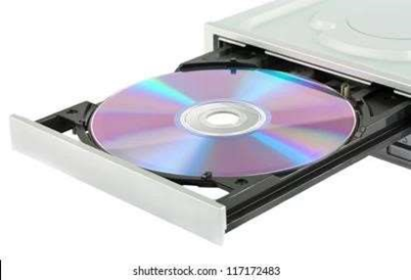**Optical Drive**

Optical Drives are used in PCs to read and write CDs and DVDs. The optical drive reads the data from the disc, which can then be transformed into a digital file that is readable by the computer. This makes it easy to backup files, play music or movies, or copy data from one disc to another. The term "CD" refers to Compact Discs, which are the most common type of optical drive on modern computers. They are often used for installing software on your computer, moving data between computers, or writing new programs.

1. **Power Supply**

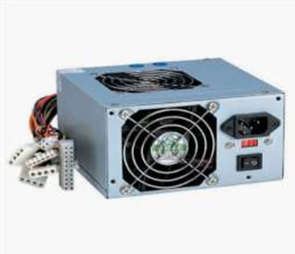A power supply is an electrical appliance that provides the necessary power to operate a computer. Computers are powered by electricity, and the power supply converts the alternating current (AC) from the electric outlet into direct current (DC). The power supply in a computer can be an internal or external component.

# Install latest version of Ubuntu on a VirtualBox

**Procedure:**

1. Download and VirtualBox Windows 10 Installation
2. Ubuntu ISO download
3. Install VirtualBox
4. Create an Ubuntu VM
5. Install Ubuntu on VirtualBox Windows 10 6. Install VirtualBox Guest Additions

**Download and VirtualBox Windows 10 Installation**

1. Install Ubuntu on VirtualBox
2. How-to Install Ubuntu on VirtualBox?
   1. Open VirtualBox
   2. Click on “New” to create a virtual machine
   3. Enter Name for your Virtual Machine
   4. Select “Linux” Operating System from “Type”
   5. Click “Next”
   6. Enter amount of memory (RAM) =1024 MBand click “Next”
   7. Click “Create” to create hard drive
   8. Click “Next”
   9. Click “Next”
   10. Enter Size of Virtual Hard Drive= 20 GBand Click “Create”
   11. Select Virtual Machine
   12. Click on “Start” to start the virtual machine
   13. Select disk file source
   14. After selecting the OS file to be installed click “Open”
   15. Click “Start”
   16. Click “Ok”
   17. Click “Install Ubuntu”
   18. Click “Continue”
   19. Click “Install Now”
   20. Click “Continue”
   21. Select location and click “Continue”
   22. Select keyboard layout & click “Continue”
   23. Fill all the details and Click “Continue”
   24. Now the installation process will start and installation window will appear
   25. Click “Restart Now”
   26. When the system will get restarted the following message will appear. Press “Enter”
   27. Close the pop-up messages by clicking on the Close (×) button
3. Steps To Maximize the Size of Ubuntu Desktop
   1. Go to “Devices”
   2. Click “Insert Guest Additions CD Image…”
   3. Click “Run”
   4. Click “Authenticate”
   5. Press “Enter”
   6. Now “Restart” your system for the changes to be applied.
   7. After the system gets restarted. Go to “View”
   8. Click “Switch to Full screen”
   9. Click “Switch”

**Output Screenshot**

**STEP 1**: Installing Virtual Box.

1. Starting pop-up window for the installation.

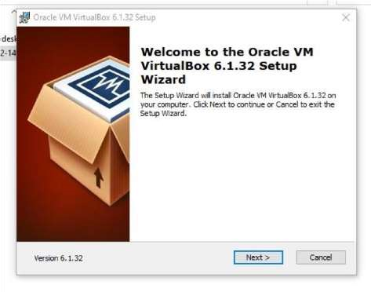

1. Custom setup window to select the features you want and select installation location

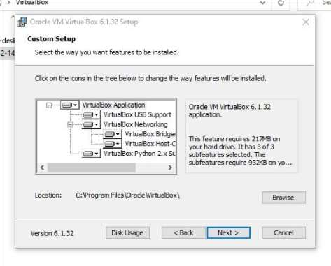

1. Custom setup window to choose from the option below.

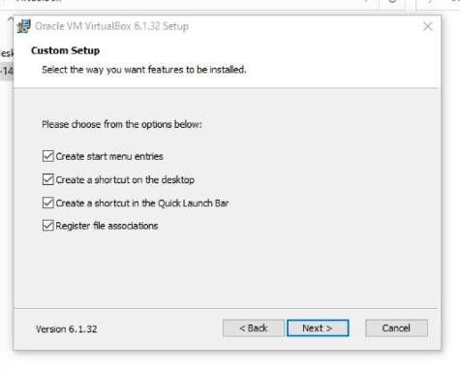

1. Custom setup window to confirm the installation.

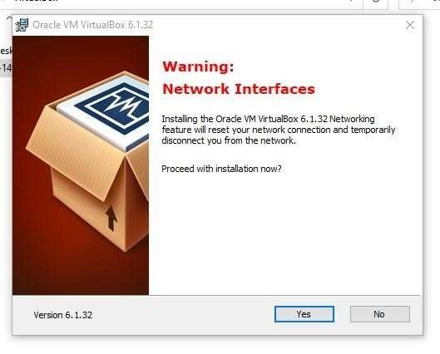

1. Custom setup window to install the virtual box with the install button.

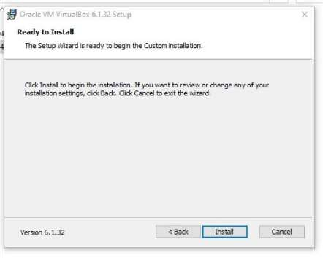

1. Installation box showing the installation status.

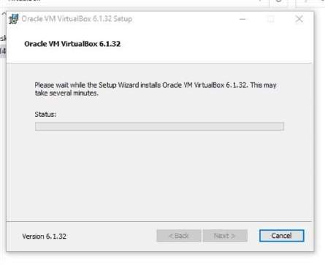

1. Installation complete pop-up windows with the finish button.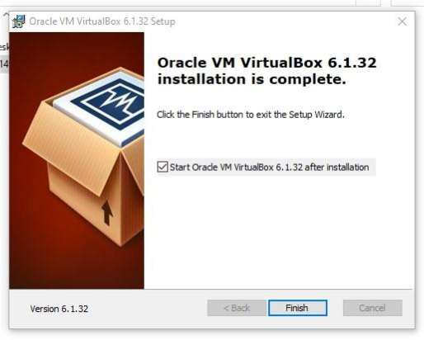

**STEP 2:** Setup the Ubuntu Instance in the VM Virtual Box.

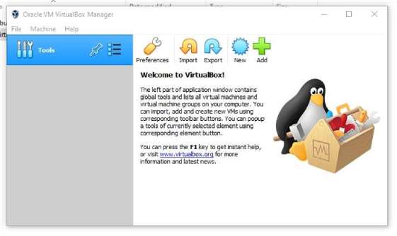

1. After selecting the NEW button to create the Ubuntu instance, the pop-up window to enter & select the name, type, and version of the OS.

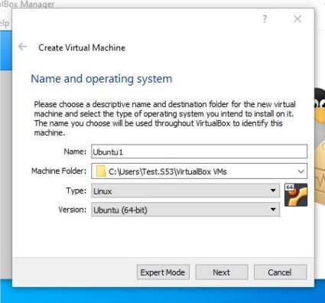

1. Choose the main memory size for the OS.

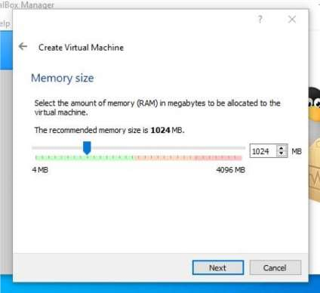

1. Option to add a virtual hard disk to the new machine instance.

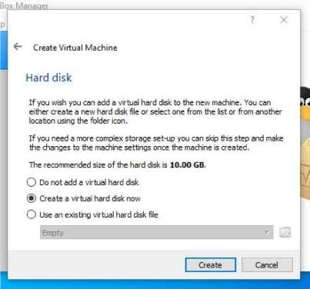

1. Option to choose the type of new virtual hard disk for new instance of OS.

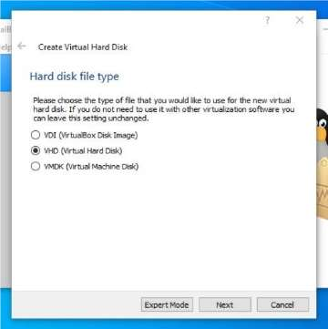

1. Options to choose the methods of accessing the physical hard disk space for the new instance from the existing hard disk

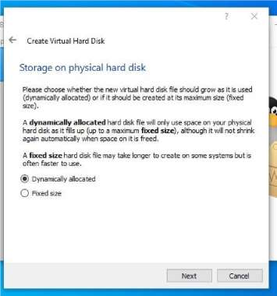

1. Panel to select the size of the virtual disk in megabytes and location and name of the instance and final submit to create the instance of OS.

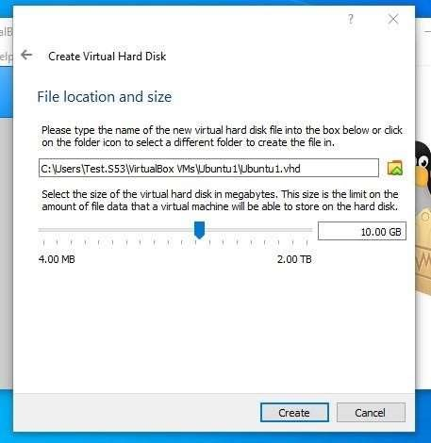

1. The newly created OS instance and at the left side of the application.

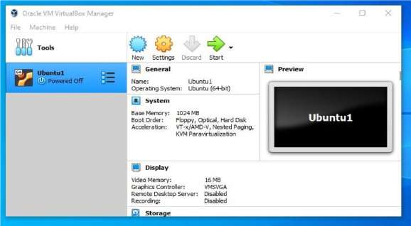

1. Settings the configurations of the instance created and adding the ISO image file of the OS correspondingly and Selecting the ISO image file from the local device.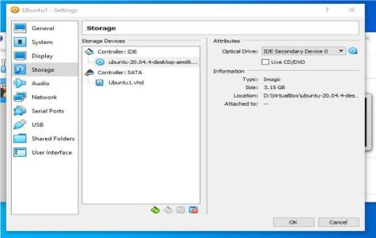

**STEP 3:** Installation of the Ubuntu OS within the newly created instance.

1. Running the new OS instance and selecting the “Install Ubuntu” to install the loaded ISO file.

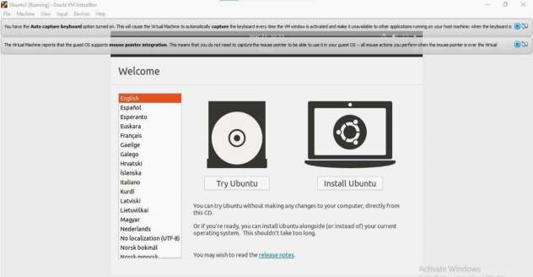

1. Selecting the language for install the ubuntu OS.

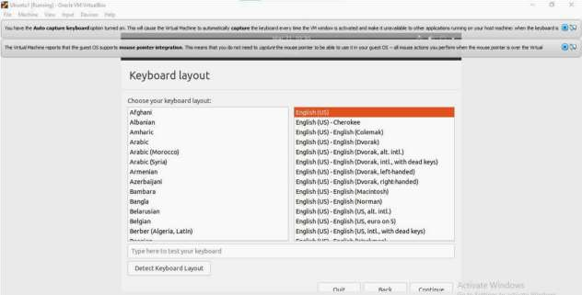

1. Selection of other installation along & within with the installation of ubuntu.

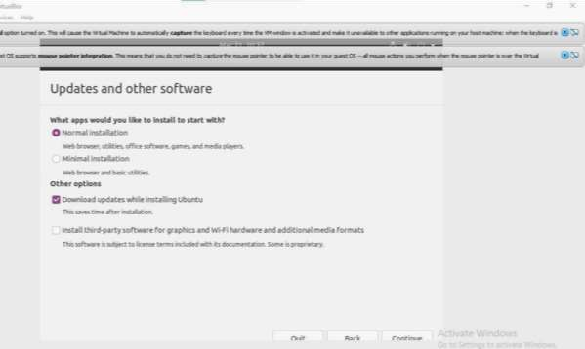

1. Selecting the disk partitioning allocation options from the given below.

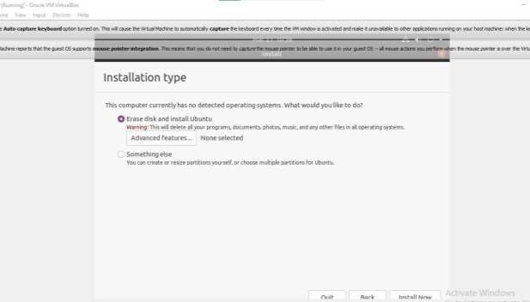

1. Selecting the geographical location for the time/location.

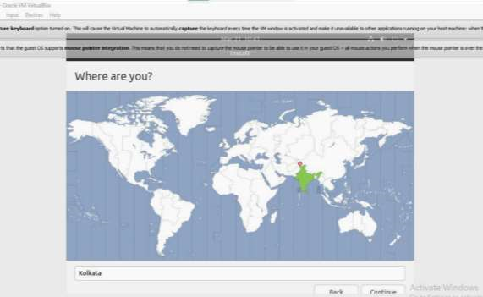

1. Entering the name, username & password for the account to sign in to the ubuntu OS after installation.

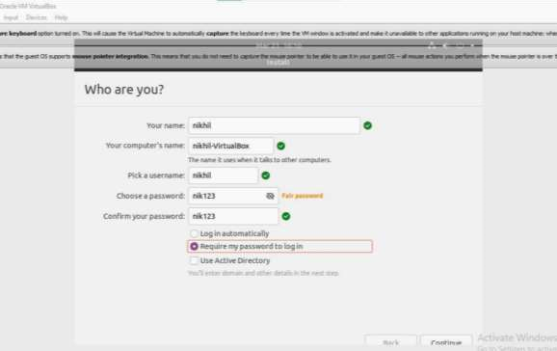

1. Installing the ubuntu OS in the instance, extracting the ubuntu ISO file, setting configurations, setting the various software within, etc.

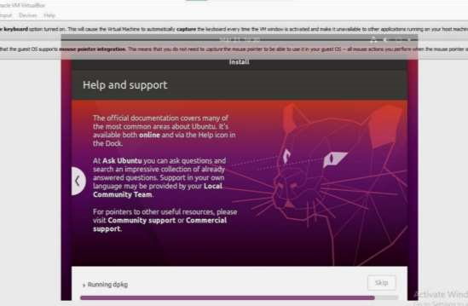

1. Restarting the OS instance to finalize the installation.

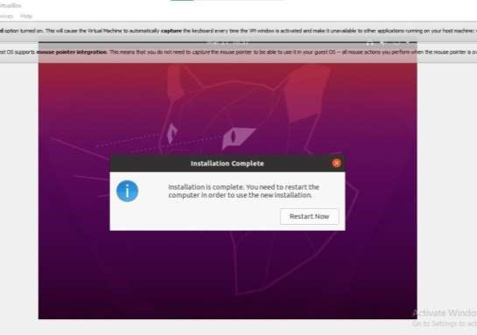

1. Signing in and visiting the home screen of the ubuntu OS using the previously registered username & password.

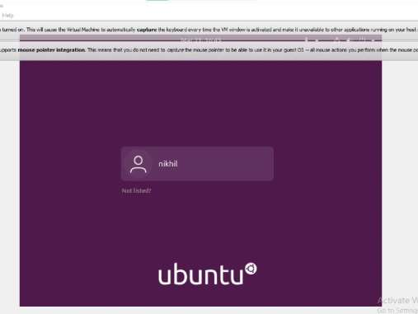

**Output**

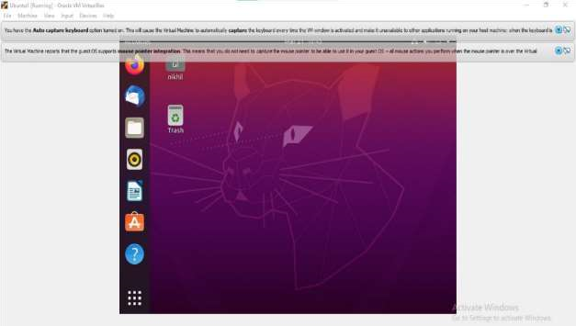

1. **Study of a terminal based text editor such as Vim or Gedit, Basic Linux commands: - familiarity with following commands/operations expected**

**Procedure**

**Pwd:** This command is used to display the location of the current working directory.

Syntax: -$ pwd

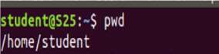

**Mkdir:** This command is used to create a new directory under any directory.

Syntax: -$ mkdir<directory name>

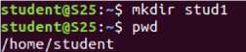

**ls:** This command is used to display a list of content of directory.

Syntax: -$ ls



**Man:** This command is used to display the user manual of any command that we can run on the terminal.

Syntax: -$ man <command name>

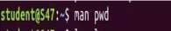

**Cd:**This command is used to change the current directory.

Syntax: -$ cd <directory name>

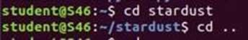

* **cd.. :** This command is used to move to the parent directory of current directory, or the directory one level up from the current directory.
* **cd –:**This command is used to switch back to previous directory we were working earlier.

**cat > filename:**This command is used to create a file and add contents to that file.

Syntax: -$ cat > filename.txt **cat filename:**This command is used to view the contents in the file.

Syntax: -$ cat filename.txt

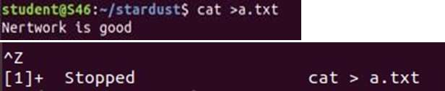

**cat>>filename**:This command is used to add contents to an existing file. Syntax: -$ cat >> filename.txt

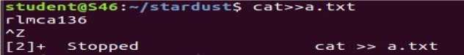

**cat filename1 > filename2**: This command is used to copy the content from one file to another file.

Syntax: -$ cat filename1 > filename2

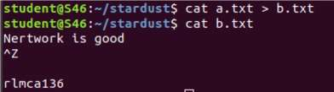

**read** :This command is used to read the content of a line to a variable.

Syntax: -$ read variablename

**Find**: This command is used to display contents of particular directory.

Syntax: -$ find filename.txt **grep** :This command will let you search through all the text in a given file.

Syntax: -$ grep word filename.txt

Output: -

* **grep -i: command** used for a case insensitive search

Syntax: $ grep -i filename.txt

* **grep -v:** command used for inverted search.

Syntax: $ grep -v filename.txt

* **grep -A1:** command used to display line after the result.

Syntax: $ grep -A1 filename.txt

* **grep -B1:** command used to display line before the result.

Syntax: $ grep -B1 filename.txt

* **grep -C1:** command used to display line before and after the result.

Syntax: $ grep -C1 filename.txt

* **wc -word count:** This command is used for counting purpose which is used to find the number of lines, the number of words, the number of characters and the number of bytes.
* **wc -l** (count number of lines)
* **wc -w** (count number of words)
* **wc -c** (count number of characters)
* **wc -m** (count number of bytes)

Syntax: - $ wc -l filename.txt

$ wc -w filename.txt

$ wc -c filename.txt

$ wc -m filename.txt

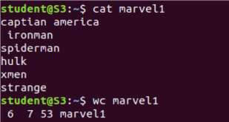

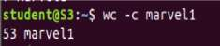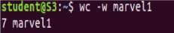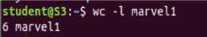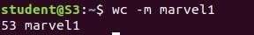

**df: This** command is used to get a report on system disc space usage.

Syntax: -$ df filename.txt

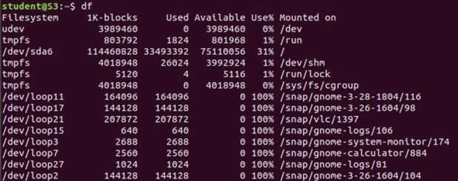

* **df -m** :This command is used to see the report in mega bytes.

Syntax: $ def -m filename.txt **cut -d**:This command is used to cut and display the content based on the delimiter given.

Syntax: -$ cut –d delimiter –fieldnumber filename

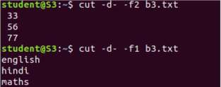

**cut -b:**This command is used tocut and display the content based on the specified byte number.

Syntax: -$ cut –b bytenumber filename

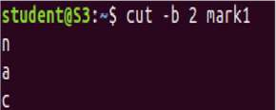

**cut --complement -c:**This command is used to erase the specified character and display the remaining content of the file.

Syntax: -$ cut --complement –c characternumber filename.txt Output

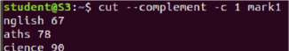

**Paste:** This command is used to paste the contents from the specified file.

Syntax: -$ paste filename

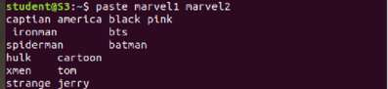

**More:** This command is used to view the text files in the command prompt, displaying one screen at a time in case the file is large.

Syntax: -$ more filename

**Cp**:This command is used to copy the contents from an existing file to a new file.

Syntax: -$ cpexisting_filenamenew_filename

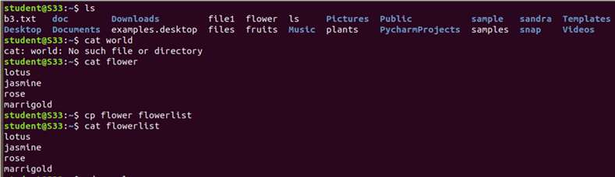

**Mv**:This command is used to move an existing file or directory from one location to another.

Syntax: -$ mv filename directory_name

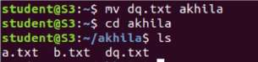

**Head**:This command is used to display the first 10 lines of the file by default. Syntax: -$ head filename

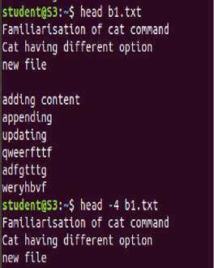

* **head -number**:This command is used to display the lines of the file to the specified number from head.

**Tail:**This command is used to display the last 10 lines of the file by default.

Syntax: -$ tail filename

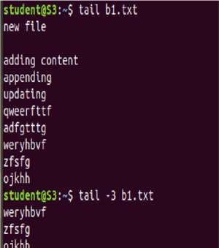

* **tail -number**:This command is used to display the lines of the file to the specified number from tail.

**sudo useradd: This** command is used to add new user.

Syntax: -$ sudo useradd username

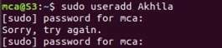

* **sudo passwd** :This command is used to add password to the user.
  + Syntax: -$ sudo passwd username
* **sudo usermod** :This command is used to add members.
  + Syntax: -$sudo usermod -G groupname username **delete**
* **sudo userdel username -** used to delete user.
* **sudo groupdel groupname -** used to delete group name.
  + Syntax: -$ sudo userdel username
* **sudo groupdel groupname chmod**: This command is used change directory permission of files.
* **chmod +rwx**
* **chmod -wx**
* **chmod -rwx**

Syntax: - $ chmod +wx filename

$ chmod -wx filename

$ chmod -rwx filename

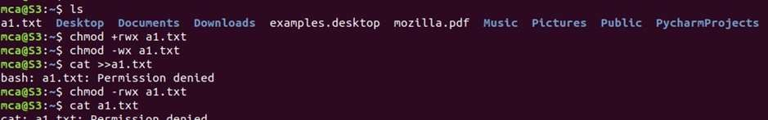

**chown:**This command is used to give ownership to user .

Syntax: - $ sudo chown username filename

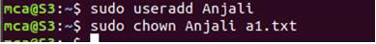

**Ssh**:This command is used to provide a secure encrypted connection between two hosts over an insecure network.

Syntax: - $ ssh mca@ipaddress

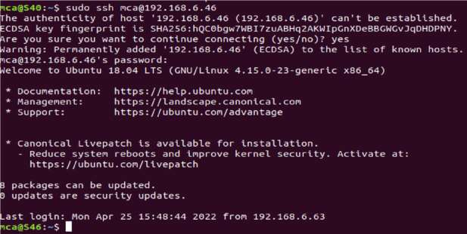

1. **Shell scripting: study bash syntax, environment variables, variables, control constructs such as if, for and while, aliases and functions, accessing command line arguments passed to shell scripts.**
2. **AIM**

Shell program to check the given number and its reverse are same.

**Source Code**

#Author: Jerry

echo "Enter a number"

read num

reverse=$(echo "$num" | rev )

if [ $num = $reverse ]

then

echo "Reverse of the number is same"

else

echo "Reverse of the number is not same"

fi

**Output**

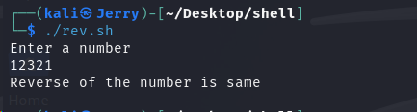

1. **AIM**

Shell program to find the sum of odd and even numbers from a set of numbers.

**Source Code**

#!/bin/bash

#Author: Jerry

echo "Enter numbers separated by space:"

read -a num

even=0

odd=0

for i in "${num[@]}"

do

if [ $((i % 2)) -eq 0 ]

then

even=$((even+i))

else

odd=$((odd+i))

fi

done

echo "Sum of even = $even"

echo "Sum of odd = $odd"

**Output**

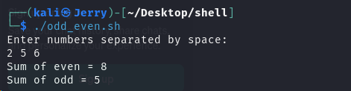

1. **AIM**

Shell program to find the roots of a quadratic equation.

**Source Code**

#!/bin/bash

#Author: Jerry

echo "Enter the coeffecient for quadratic equation (a,b,c)"

read a b c

dis=$((b*b-4*a*c))

if [ $dis -lt 0 ]

then

echo "Thequadratic has no root"

else

root1=$(echo "scale=2; (-$b + sqrt($dis)) / (2*$a)" | bc)

root2=$(echo "scale=2; (-$b - sqrt($dis)) / (2*$a)" | bc)

echo "root of the quadratic equations are :$root1 and $root2"

fi

**Output**

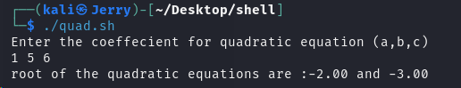

1. **AIM**

Shell program to generate prime numbers between 1 and 50.

**Source Code**

#!/bin/bash

#Author: Jerry

for ((i=2;i<=50;i++))

do

x=0

for ((j=2; j<=i/2; j++))

do

if [ $((i%j)) == 0 ]

then

x=1

break

fi

done

if [ $x == 0 ]

then

echo -n " $i"

fi

done

**Output**

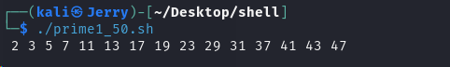

1. **AIM**

Shell program to find the sum of digits of a number using function.

**Source Code**

#!/bin/bash

#Author: Jerry

function n_sum() {

local num="$1"

local sum=0

while ((num > 0))

do

sum=$((sum + num%10))

num=$((num/10))

done

echo $sum

}

echo "Enter a number"

read n

result=$(n_sum "$n")

echo "Result= $result"

**Output**

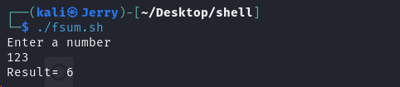

1. **AIM**

Shell program to print the reverse of a number using function.

**Source Code**

#!/bin/bash

#Author: Jerry

function rev(){

local num=$1

local rev=0

while ((num != 0))

do

rev=$((rev*10))

rev=$((rev+num%10))

num=$((num/10))

done

echo "Reverse = $rev"

}

echo "Enter a number"

read n

rev "$n"

**Output**

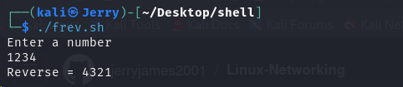

1. **AIM**

Shell script, which receives two filenames as arguments. It checks whether the two files’ contents are same or not. If they are same then second file is deleted.

**Source Code**

#!/bin/bash

#Author: Jerry

file1="$1" # eg) ./file_comp.sh <file1name> <file2name>

file2="$2"

if [ ! -f $file1 ]

then

echo "File 1 does not exist"

fi

if [ ! -f $file2 ]

then

echo "File 2 does not exist"

fi

if cmp -s $file1 $file2

then

echo "File 1 and file 2 has same contents"

echo "Removing $file2"

rm $file2

else

echo "File 1 and file 2 has different contents"

fi

**Output**

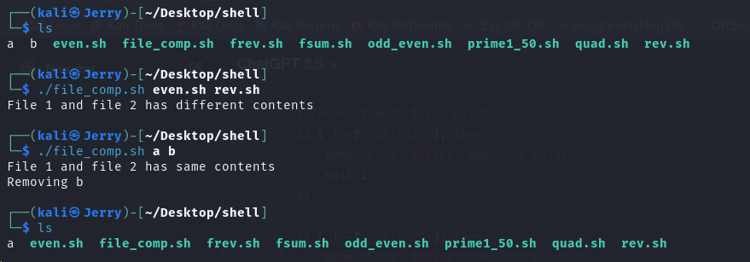

1. **AIM**

Shell script to check executable rights for all files in the current directory, if a file does not have the execute permission, then make it executable.

**Source Code**

#!/bin/bash

#Author: Jerry

for file in *

do

if [ -f $file ] && [ ! -x $file ]

then

ls -l "$file"

echo

echo "This $file is not executable"

echo "Converting to an executabkle file.."

echo

chmod +x "$file"

ls -l "$file"

fi

done

**Output**

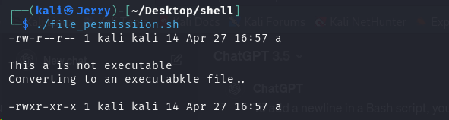

1. **AIM**

Shell program to create Pascal’s triangle.

**Source Code**

#!/bin/bash

#Author: Jerry

# Function to calculate binomial coefficient

calculate_coefficient() {

local n=$1

local k=$2

local result=1

local i

for ((i=1; i<=k; i++))

do

result=$((result * (n - i + 1) / i))

done

echo $result

}

# Function to generate Pascal's triangle

generate_triangle() {

local rows=$1

local i j

for ((i=0; i<$rows; i++))

do

for ((j=0; j<=$i; j++))

do

coefficient=$(calculate_coefficient $i $j)

echo -n " $coefficient "

done

echo

done

}

generate_triangle 5

**Output**

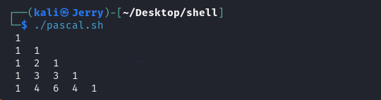

1. **AIM**

Shell script to find out the unique words in a file and count the occurrence of each of these words

**Source Code**

#!/bin/bash

#Author: Jerry

file="$1"

if [ ! -f $file ]

then

echo "File not found"

exit

fi

tr -s ' ' '\n' < "$file" | sort | uniq -c

**Output**

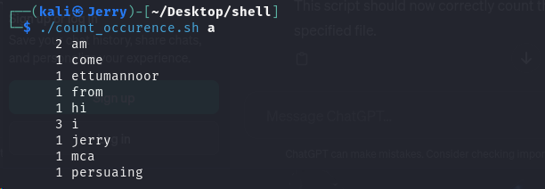

1. **File system hierarchy in a common Linux distribution**

The Linux File Hierarchy Structure or the Filesystem Hierarchy Standard (FHS) defines the directory structure and directory contents in Unix-like operating systems. It is maintained by the Linux Foundation.

* In the FHS, all files and directories appear under the root directory /, even if they are stored on different physical or virtual devices.
* Some of these directories only exist on a particular system if certain subsystems, such as the X Window System, are installed.
* Most of these directories exist in all UNIX operating systems and are generally used in much the same way; however, the descriptions here are those used specifically for the FHS, and are not considered authoritative for platforms other than Linux.

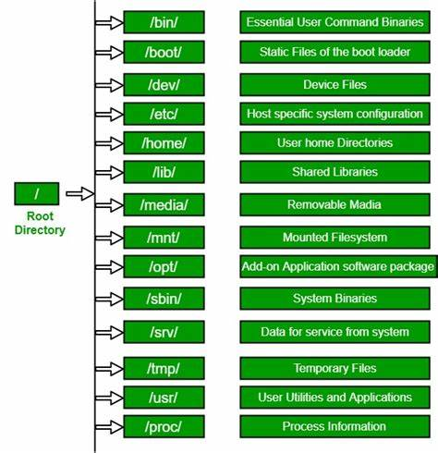

**Root directory**

The root directory, denoted by a forward slash (**/**), marks the starting point of the Linux File System. It is positioned at the topmost level, serving as the foundation for the entire file system. All other directories are classified as children or grandchildren of the rootdirectory.

### /home directory

The /**home** directory serves as a private directory for each user, containing individual user home directories such as Documents, Downloads, Desktop, Pictures, etc. Each registered user on the system has their own subdirectory within /home. This directory ensures user privacy and isolates user data from system-wide files.

### /bin directory

The **/bin** directory holds essential binary files (executables) that are essential for the proper functioning of the system. For example, basic Linux commands like **cp, ls,**and **echo**exist as binary files within the **/bin** directory. These files are accessible to all users.

**/boot**

The /boot directory contains the files needed to boot the system – for example, the GRUB boot loader’s files and your Linux kernels are stored here. The boot loader’s configuration files are not located here, though – they are in /etc with the other configuration files.

**/dev**

Linux exposes devices as files, and the /dev directory contains several special files that represent devices. These are not actual files as we know them, but they appear as files – for example, /dev/sda represents the first SATA drive in the system. If you wanted to partition it, you could start a partition editor and tell it to edit /dev/sda. This directory also contains pseudo-devices, which are virtual devices that do not actually correspond to hardware. For example, /dev/random produces random numbers. /dev/null is a special device that produces no output and automatically discards all input – when you pipe the output of a command to /dev/null, you discard it.

**/lib**

The /lib directory contains libraries needed by the essential binaries in the /bin and /sbin folder. Libraries needed by the binaries in the /usr/bin folder are in /usr/lib.

**/media**

The /media directory contains subdirectories where removable media devices inserted into the computer are mounted. For example, when you insert a CD into your Linux system, a directory will automatically be created inside the /media directory. You can access the contents of the CD inside this directory.

**/mnt**

Historically speaking, the /mnt directory is where system administrators mounted temporary file systems while using them. For example, if you’re mounting a Windows partition to perform some file recovery operations, you might mount it at /mnt/windows. However, you can mount other file systems anywhere on the system.**/opt**

The /opt directory contains subdirectories for optional software packages. It is commonly used by proprietary software that does not obey the standard file system hierarchy – for example, a proprietary program might dump its files in /opt/application when you install it.

**/proc**

The /proc directory like the /dev directory because it does not contain standard files. It contains special files that represent system and process information.

**/sbin**

The /sbin directory is like the /bin directory. It contains essential binaries that are generally intended to be run by the root user for system administration

**/srv**

The /srv directory contains “data for services provided by the system.” If you were using the Apache HTTP server to serve a website, you’d likely store your website’s files in a directory inside the /srv directory.

**/tmp**

Applications store temporary files in the /tmp directory. These files are generally deleted whenever your system is restarted and may be deleted at any time by utilities such as tmpwatch**.**

**/usr**

The /usr directory contains applications and files used by users, as opposed to applications and files used by the system. For example, non-essential applications are located inside the /usr/bin directory instead of the /bin directory and non-essential system administration binaries are in the /usr/sbin directory instead of the /sbin directory. Libraries for each are located inside the /usr/lib directory. The /usr directory also contains other directories – for example, architecture-independent files like graphics are in /usr/share. The /usr/local directory is where locally compiled applications install to by default – this prevents them from mucking up the rest of the system.

1. **Installation and configuration of LAMP stack. Deploy in an open-source application such as phpMyAdmin and WordPress.**

**Procedure**

**Install Apache2**

* **Update your system:**

sudo apt update

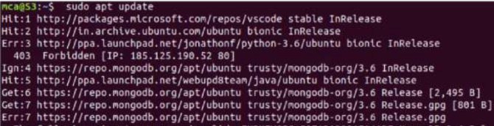

* **Install Apache using apt:**

sudo apt install apache2

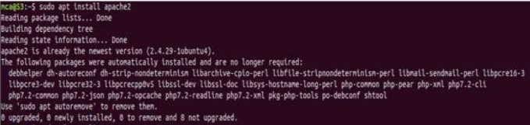

**Confirm that Apache is now running with the following command:**

sudo systemctl status apache2

* **If it is not working !**

sudo systemctl stop apache2 # to stop if running

sudo systemctl start apache2 # to start if not running

* **Once installed, test by accessing your server’s IP in your browser:**

<http://127.0.0.1/>

<http://localhost/>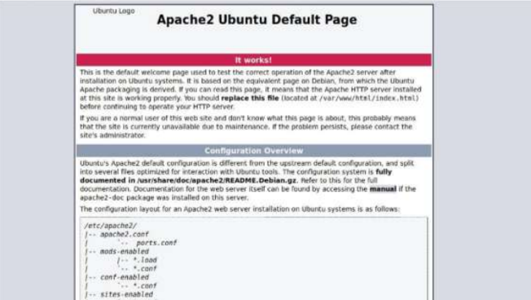

**Install mariadb**

sudo apt install mariadb-server mariadb-client

sudo systemctl status mysql # to check status

sudo systemctl start mysql # if not running

sudo mysql_secure_installation # Secure your newly installed MariaDB

**Install PHP and commonly used modules**

* sudo apt install php libapache2-mod-php php-apcache php-cli php-gd php- curl php-mysql
* sudo systemctl restart apache2
* **Test PHP Processing on Web Server**
* sudo nano /var/www/html/phpinfo.php
* **Inside the file, type in the valid PHP code:**

<?php

phpinfo ();

?>

* **Press CTRL + X to save and close the file. Press y and ENTER to confirm Open a browser and type in your IP address/phpinfo.php**

http://127.0.0.1/phpinfo.php

Install phpmyadmin

sudo apt install phpmyadmin php-mbstring php-zip php-gd php-json php-

curl

sudo systemctl restart apache2

* **Open a browser: http://localhost/phpmyadmin**

**username: root**

**password: yourpassword If php my admin page not found:**

nano /etc/apache2/apache2.conf

* **Add this line to last of the file.**

**Press CTRL + X to save and close the file. Press y and ENTER to**

**confirm**

Include /etc/phpmyadmin/apache.conf

* **restart apache2 - now try: http://localhost/phpmyadmin**

sudo systemctl restart apache2

* **If any problem for login run the following command**

**sudo mysql**

ALTER USER root@localhost IDENTIFIED BY "yourpassword";

**Install WordPress with LAMP on Ubuntu 18.04**

**Step 1 – Download WordPress**

Download the latest version of the WordPress package and extract it by

issuing the commands below on the terminal:

* wget -c <http://wordpress.org/latest.tar.gz>

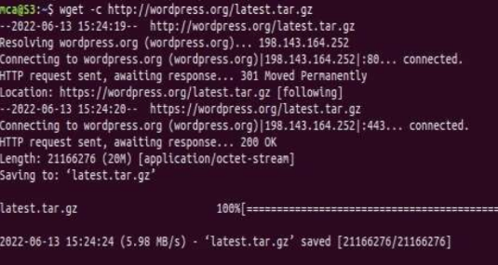

* tar -xzvf latest.tar.gz

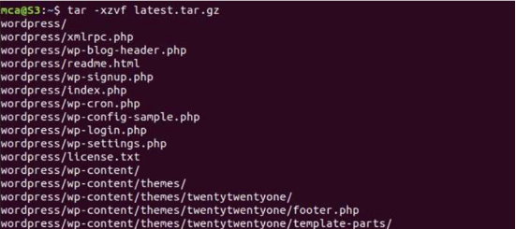

Then move the WordPress files from the extracted folder to the Apache

default root directory, /var/www/html/:

* sudo mv wordpress/* /var/www/html/

Next, set the correct permissions on the website directory, that is give

ownership of the WordPress files to the webserver as follows:

* sudo chown -R www-data:www-data /var/www/html/
* sudo chmod -R 755 /var/www/html/

**Step 2 – Creating a MySQL Database and User for WordPress**

The first step you will take is a preparatory one. Even though MySQL is already installed, you still need to create a database to manage and store the user information for WordPress to use. To get started, log into the MySQL root(administrative) account by issuing the following command:

* sudo mysql

You will be prompted for the password you set for the MySQL root account when you installed the software. However, if you have password authentication enabled for your root user, you can run the following command and enter your password information when prompted:

* mysql -u root –p

From there, you will create a new database that WordPress will control. You can call this whatever you would like, but we will be using WordPress in this guide an example. Create the database for WordPress by writing the following:

* CREATE DATABASE WordPress DEFAULT CHARACTER

SET utf8 COLLATE utf8_unicode_ci;

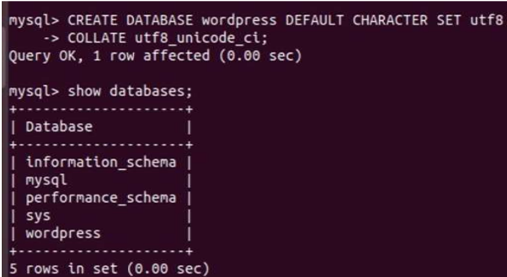

Next, you are going to create a separate MySQL user account that you will use exclusively to operate on the new database. Creating one-function databases and accounts is a good idea from a management and security standpoint. We will use the name WordPress user as an example in this guide. Feel free to change this if you would like. You can create this account,

set a password for it, and then grant it access to thedatabase you created all by running the following command. Remember tochoose a strong password here for your database user:

* GRANT ALL ON wordpress.* TO

'wordpressuser'@'localhost'IDENTIFIED BY 'password';

After creating this user, flush the privileges to ensure that the current instance ofMySQL knows about the recent changes you’ve made:

* FLUSH PRIVILEGES;

Exit out of MySQL:

* EXIT

You now have a database and user account in MySQL, each made specifically for WordPress. Go the /var/www/html/ directory and rename existing wp-config-sample.php to wpconfig.php. Also, make sure to remove the default Apache index page.

* cd /var/www/html/
* sudo mv wp-config-sample.php wp-config.php
* sudo rm -rf index.html







Then update it with your database information under the MySQL settings section (refer to the highlighted boxes in the image below): This setting can be added after the database connection settings, or anywhere else in the file: Save and close the file when you are finished. Restart the web server and mysql service using the commands below:

* sudo systemctl restart apache2.service
* sudo systemctl restart mysql.service



**Step 3 – Completing the Installation Through the Web Interface**

Now that the server configuration is complete, you can complete the installation through the web interface. In your web browser, navigate to your server’s domain name or public IP address:

* https://server_domain_or_IP

Select the language you would like to use: Next you will be directed to the main setup page. Select a name for your WordPress site and choose a username (it is recommended not to choose something like “admin” for security purposes). A strong password is generated automatically. Save this password or select an alternative strong password. Enter your email address and select whether you want to discourage search engines from indexing your site: Once you log in, you will be taken to the WordPress administration dashboard: From there, you can begin using and customizing your WordPress site

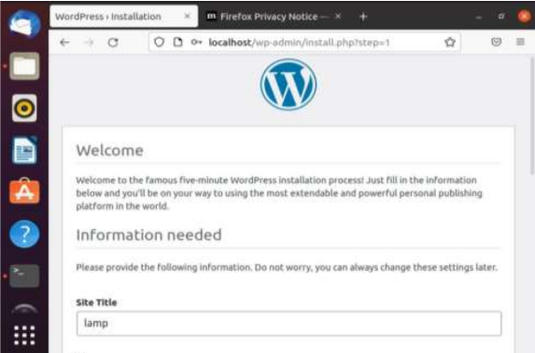

Once you log in, you will be taken to the WordPress administration dashboard: From there, you can begin using and customizing your WordPress site.

1. **Build and install software from source code, familiarity with make and cmake utilities expected.**

Install the cmake

**Apt show cmake**

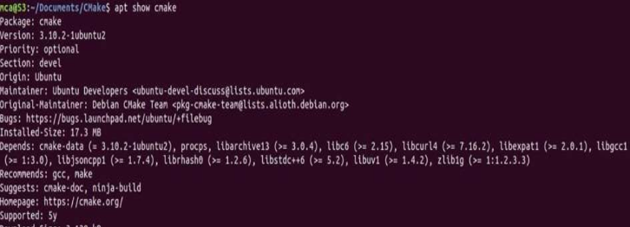

* **$sudo apt install cmake g++ make:** To install cmake , g++ and make using the apt command.

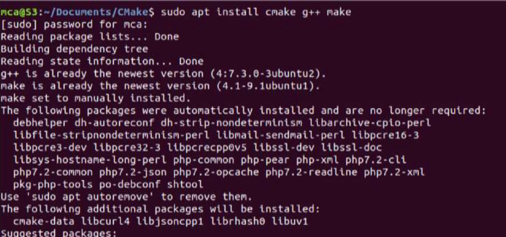

**Create directory**

* **mkdir cmake**: creating a different directory for our project using the mkdir and cd commands.



* **Cd cmake**



* **gedit Helloworld.cpp**

Now create a C++ source file named Hello_world.cpp and add the following **:**

* **gedit CmakeLists.txt**

Create a CMakeLists.txt file(with this exact capitalization) which is required by CMake:

**Create directory called Mkdir build:**

To run cmake we need to change into the build directory:

**Cmake..**

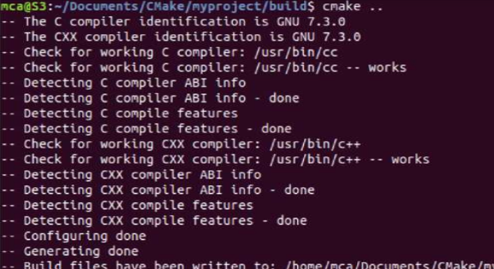

* Cmake –build : To generate the executable simply by typing: run hello

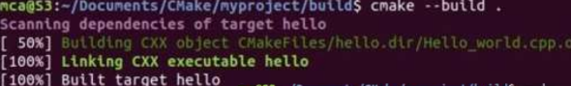

* ./hello: Run the executable by typing:



1. **Introduction to command line tools for networking IPv4 networking, network commands**
2. **ifconfig**: This commands in windows allows you to see a summarized information of your network such as Ip address, subnet mask, server address etc.

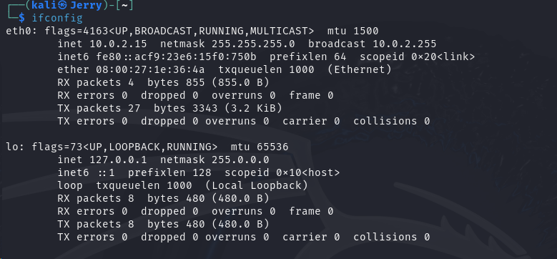

1. **nslookup**: To show the server to which the system is connected by default. If we want to find the Ip address of a particular domain name, we can also use nslookup

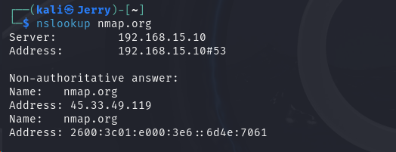

1. 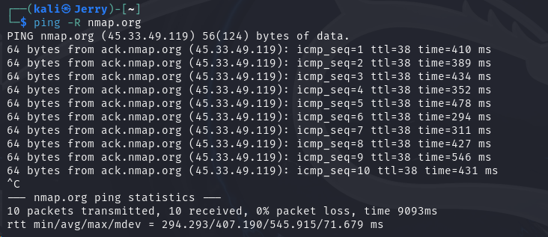**ping:** The command used to check the availability of a host. The response shows the URL you are pinging, the Ip address associated with the URL and the size of packets being sent on the first line. The next four lines shows the replies from each individual packets including the time (in milliseconds) for the response and the time to live (TLL) of the packet, that is the amount of time that must pass before the packet discarded.
2. **traceroute:** traceroute is a command-line utility in Linux and other Unix-like operating systems that allows you to track the path that packets take from your computer to a destination host on a network. It is used for troubleshooting network connectivity issues and identifying network delays.

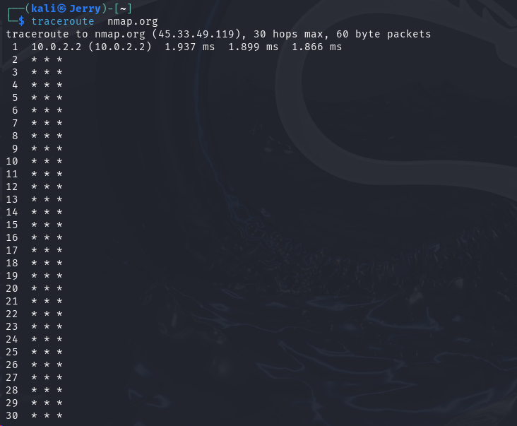

1. 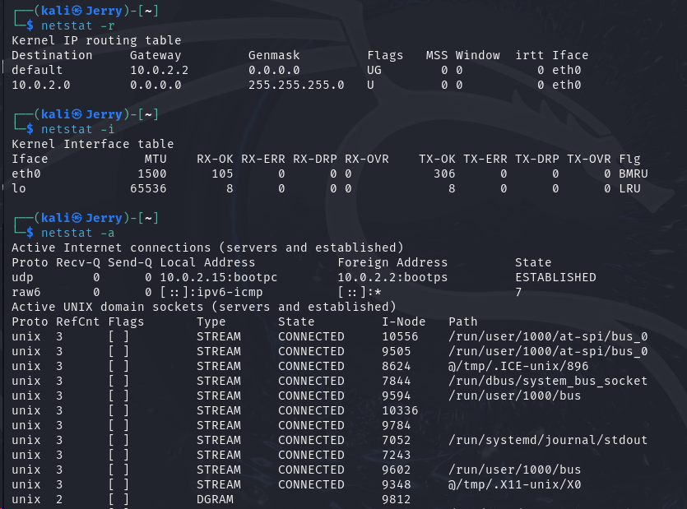**netstat:** netstat is a command-line utility in Linux and other Unix-like operating systems that provides information about network connections, routing tables, interface statistics, masquerade connections, and more. It's used for monitoring network-related information and diagnosing network issues.
2. **hostname:** The hostname command is a command-line utility in Linux and other Unix-like operating systems that allow you to view or set the hostname of the system. The hostname is the unique name assigned to a computer within a network.

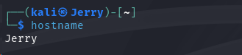

1. **arp:** The arp command is a command-line utility in Linux and other Unix-like operating systems that allows you to view and manipulate the Address Resolution Protocol (ARP) cache, which is used to map IP addresses to MAC addresses on a local network. ARP is essential for communication between devices within the same subnet.

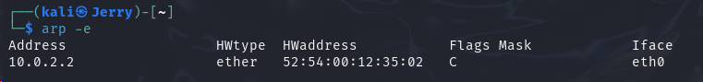

1. **uname:** The uname command is a command-line utility in Linux and other Unix-like operating systems that provides information about the system's kernel and operating system. It's used to retrieve information about the system's architecture, release version, and other details.



1. **Analyzing network packet stream using tcpdump and Wireshark.**

**tcpdump**

The tcpdump utility runs on the Linux command line. Tcpdump is a simple application that works well in Linux servers without Linux-based network devices, a GUI or various IoT nodes. These attributes give tcpdump an advantage over more powerful GUI-based analyzers, like Wireshark. Tcpdump is also scriptable, which means it can enable scheduled captures.

* **sudo tcpdump -i eth0 host 192.168.1.100**

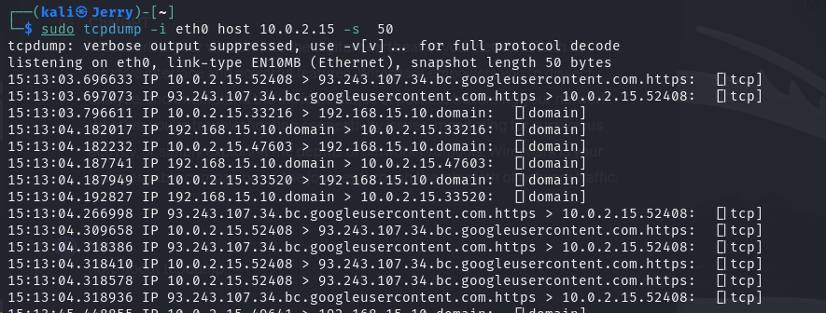 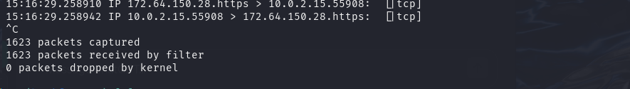

**Wireshark**

Wireshark is a powerful network protocol analyser that allows you to capture and interactively browse the traffic running on a computer network. Here are some key points to note about Wireshark:

1. **Packet Capture**: Wireshark captures packets from a network interface in real-time or from a previously saved capture file. It supports a wide range of network protocols and can dissect and display their contents.
2. **Packet Analysis**: Wireshark provides detailed packet analysis capabilities, allowing you to inspect packet headers, payloads, and other protocol-specific information. It can decode hundreds of protocols and display them in a human-readable format.
3. **Filtering**: Wireshark offers powerful filtering capabilities, allowing you to focus on specific types of traffic based on various criteria such as IP addresses, ports, protocols, and packet contents. Filters help in efficiently analysing network traffic.
4. **Statistics**: Wireshark provides various statistics tools to analyse network traffic patterns, including endpoint statistics, protocol hierarchy, packet length distribution, and more. These statistics help in understanding network behaviour and troubleshooting network issues.
5. **Protocol Support**: Wireshark supports a vast number of network protocols, including common ones like TCP, UDP, HTTP, DNS, and more obscure or proprietary protocols. It can dissect and decode protocol data units (PDUs) for a comprehensive analysis.
6. **Graphical Interface**: Wireshark features a user-friendly graphical interface that allows you to interactively explore captured packets. It provides various views, including packet list, packet details, and packet bytes, along with customizable colorization and layout options.
7. **Cross-Platform**: Wireshark is cross-platform and runs on Windows, macOS, and Linux. It offers consistent features and capabilities across different operating systems, making it a versatile tool for network analysis.
8. **Community Support**: Wireshark has a large and active user community that contributes to its development and provides support through forums, mailing lists, and documentation. The community also maintains a repository of capture files for learning and reference purposes.

Overall, Wireshark is an essential tool for network administrators, security professionals, and anyone involved in network troubleshooting, analysis, or monitoring. Its comprehensive features, protocol support, and user-friendly interface make it an asset for understanding and debugging network communications.

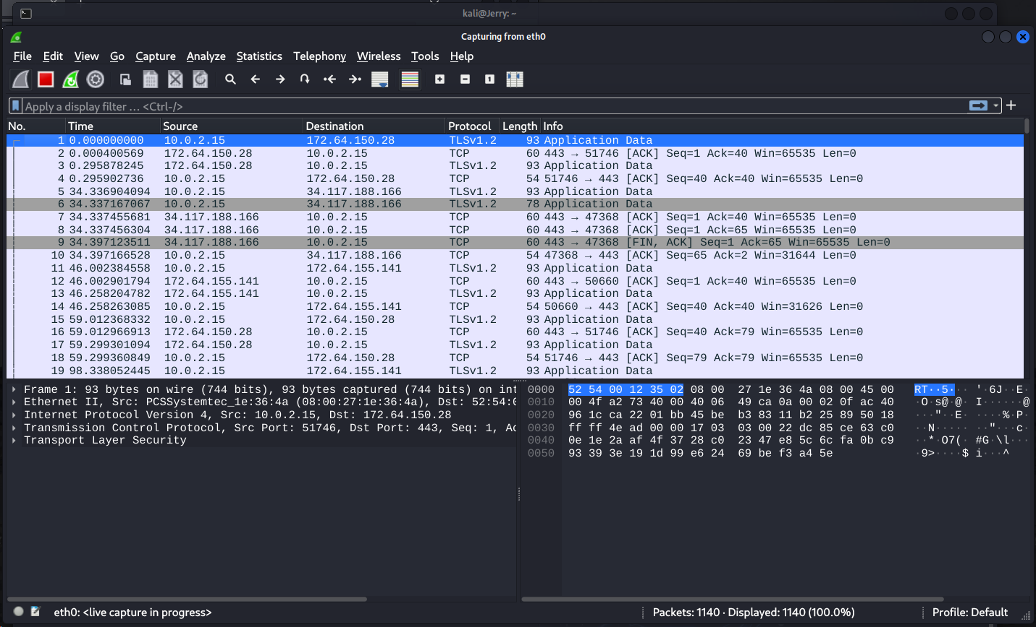

1. **Introduction to Hypervisors and VMs, Xen or KVM Introduction to Containers: Docker, installation, and deployment.**

**Procedure**

For the Ubuntu system, all packages required to run KVM are available on official upstream repositories.

Install them using the commands:

* sudo apt update
* sudo apt-get install qemu qemu-kvm libvirt-bin bridge-utils virt-manager virtviewer–y

Create Virtual Machine

* You can create virtual machine using virt-manager utility.

Run the following command to start the virt-manager:

sudo virt-manager

* virsh help
* virsh help
* virsh help list
* Sudo virsh nodeinfo
* Virsh start
* vm virsh start
* virsh start testvm1

**Step 1:** Update the repositories

**Step 2:** Install essential KVM packages

Install virt-manager, a tool for creating and managing VMs

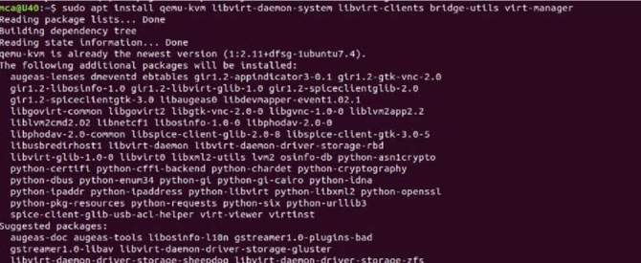

**Step 3:** Start virt-manager with

**Step 4:**In the first window, click the computer icon in the upper-left corner, In the dialogue box that opens, select the option to install the VM using an ISO image. Then click Forward.

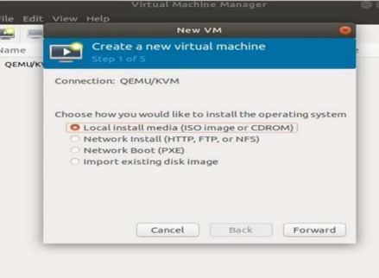

**Step 5:** Choose ISO, click Forward

**Step 6:** Enter the amount of RAM and the number of CPUs you wish to allocate to the VM and proceed to the next step.

**Step 7:** Allocate hard disk space to the VM. Click Forward to go to the last step.

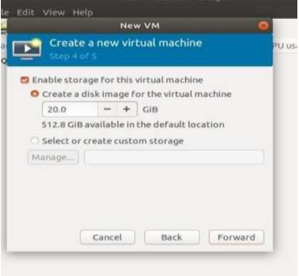

**Step 8:** Specify the name for your VM and click Finish to complete the setup.

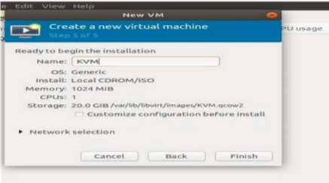

**Step 9:** Select language

**Step 10:** The VM starts automatically, prompting you to start installing the OS that is on the ISO file.

**Step 11:** Check the state of KVM

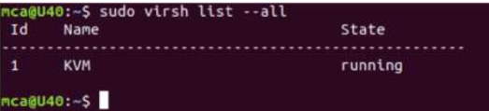

**Introduction to Containers: Docker installation and deployment**

**Procedure**

**Steps for Installing Docker:**

**Step 1:** Open the terminal on Ubuntu.

**Step 2:** Remove any Docker files that are running in the system, using the following command

* Command: $ sudo apt-get remove docker docker-engine docker.io

After entering the above command, you will need to enter the password of the root and press enter.

**Step 3:** Check if the system is up-to-date using the following command:

* Command: $ sudo apt-get update

**Step 4:** Install Docker using the following command:

* Command: $ sudo apt install docker.io

You will then get a prompt asking you to choose between y/n – choose ‘y’

**Step 5:** Install all the dependency packages using the following command:

* Command: $ sudo snap install docker

**Step 6:** Before testing Docker, check the version installed using the following command:

* Command: $ docker –version

**Step 7:** Pull an image from the Docker hub using the following command:

* Command: $ sudo docker run hello-world

Here, hello-world is the docker image present on the Docker hub.

**Step 8:** Check if the docker image has been pulled and is present in your system using the

following command:

* Command: $ sudo docker images

Step 9: To display all the containers pulled, use the following command:

* Command: $ sudo docker ps -a

Step 10: To check for containers in a running state, use the following command:

* Command: $ sudo docker ps

1. **Installing and configuring modern frameworks like Laravel**

**Step 1: Prerequisites**

* Install Required Software: Make sure you have a web server (e.g., Apache or Nginx), PHP, Composer (dependency manager), and a database server (e.g., MySQL) installed on your system.
* **Install Composer:** Download and install Composer by following the instructions on

the official Composer website.

**Step 2: Install Laravel**

**1. Create a New Laravel Project:** Open a terminal and navigate to the directory where you want to create your Laravel project. Run the following command:

* composer create-project --prefer-dist laravel/laravel myproject

This will create a new Laravel project named "myproject."

**Step 3: Configure the Web Server**

**1. Apache:**

* Create a new virtual host configuration for your Laravel project in your Apache configuration.
* Set the Document Root to the public directory of your Laravel project.
* Enable the necessary Apache modules (e.g., rewrite) and restart Apache.

**2. Nginx:**

* Create a new server block configuration for your Laravel project in your Nginx configuration.
* Set the root directive to the public directory of your Laravel project.
* Configure the necessary location directives and restart Nginx.

**Step 4: Configure Laravel**

**1. Environment Configuration:**

* Rename the. env.example file in your Laravel project root to. env.
* Set database connection details, application key, and other settings in the .env file.

**2. Generate Application Key:** Run the following command in your Laravel project directory:

* php artisan key: generate

**3. Run Migrations:** If your .env file is configured with database details, run migrations

to create necessary database tables:

* php artisan migrate

**Step 5: Testing the Setup**

1. **Access the Application**: Open a web browser and visit the URL you configured for your Laravel project. You should see the Laravel welcome page.
2. **Create Routes and Views:** Begin building your application by defining routes and creating views in the resources/views directory.
3. **Ansible play book deployment**

**Ansible playbooks** are the cornerstones of automation in Ansible. They define a set of instructions (tasks) that Ansible executes on remote systems (managed nodes) to achieve a desired configuration state.

Here are some key points about Ansible playbook deployment:

* **Reusability and Orchestration**: Playbooks are reusable, allowing you to deploy complex applications or configurations across multiple machines with consistency. They can orchestrate the deployment process, running specific tasks on different groups of hosts based on their roles (e.g., web servers, database servers).
* **Declarative Nature**: Playbooks are declarative, meaning they specify the desired end state rather than the specific steps to achieve it. This makes them easier to understand and maintain. Ansible figures out the most efficient way to reach the desired state.
* **Inventory Management**: Playbooks rely on an inventory file that defines the managed nodes and groups of nodes. This allows you to target specific groups for deployment tasks.
* **Roles**: Playbooks can leverage roles, which are reusable modules containing related tasks for specific functionalities. This promotes modularity and simplifies playbook structure.

**Installation**

Prerequisites: pip & python 3

Check version: python3 -m pip -V

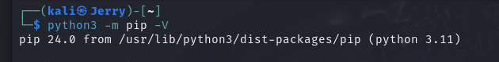

Installation: python3 -m pip install --user ansible-core

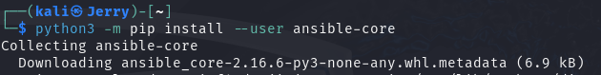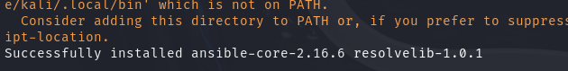

Upgrade: python3 -m pip install --upgrade --user ansible

